

Huawei 4G Parsing

FRS (Functional Requirement Specifications)
Auto-Import

Connector Name:
Huawei_RAN_Ooredoo_Tunisia

Change History

Version | Change Description | Author | Date
0.1 | First draft. | Indrasan Yadav | 05-05-2025
0.2 | Update the rule to parse UP/DN channel bandwidth under section 5.1 highlight with green color. | Indrasan Yadav | 20-01-2026

Preamble

Logical

- This document specifies how to parse the logical inventory attributes for the eNodeB and its cells.
- It covers the parameters defined for eNodeB RAN Logical attributes.
- The provided dump files are of “.xml”.
- For Ooredoo Tunisia, each eNodeB logical dump file is separate.
- This is motivated by Oman-Tel/ZAIN-KSA Projects and can be used for other operators having same file structure.

Interfaces

- This connector is prepared for R008 or higher (R009, R010, etc.) software version and higher.
- Software version to be deduced from the value of attribute neversion=”XYZ” under header line <spec:fileHeader in logical dumps which will be in starting.
- neversion contains “VxxxRyyy”, e.g. neversion="BTS3900 V100R019C10SPC260", software version is equal to 3 digits after “R” →” R019”.
- This document specifies how to parse the logical inventory attributes of below HUAWEI 4G interfaces:
  - S1-U connecting eNodeB to SGW.
  - S1-MME connecting eNodeB to MME.
  - X2 connecting eNodeB to eNodeB.
- S1-U and S1-MME physical connection to be defined temporarily from eNodeB side only, Core Element physical connection to be added after introducing the core module.

Dump Structure

Dumps are provided in 2 different structures:

1st Structure type:

Dumps are provided in 2 parts but in same structure 1st one will be physical in .xml & 2nd one will be logical in .xml file for each node of eNodeB:

- One XML file per eNodeB node.
- The dump file is an “.xml” file composed of set of Classes.
- Each Class starts with <class> and ends </class>.
- Class Name is the attribute mentioned directly beneath <class>.
- Attributes are found between <>, e.g. = <IP> attribute under <attributes> under <DEVIP>

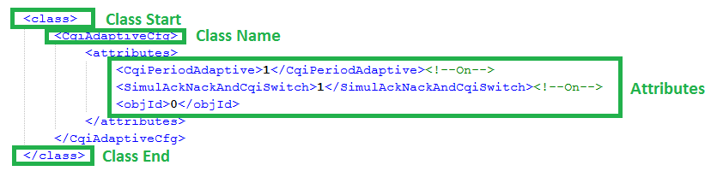

2nd Structure type:

- The provided dumps are one or multiple XML files for the whole network
- This dump contains all the logical configuration for the nodes
- The dump consists of multiple <subsession> section
- Each <subsession> contains the configuration of one node

Attributes are found between “”, e.g. “IP” attribute under the class the has the type “DEVIP”.

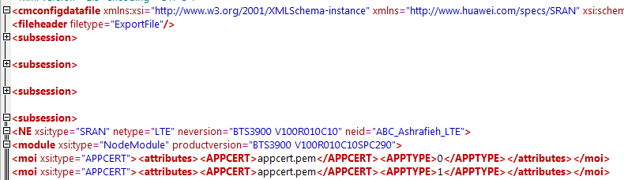
Class Type
Attributes
One Class
One node configuration

eNodeB logical parameters

The eNodeB logical inventory attributes are classified as per the below categories:
  - Global Parameters
  - Networking Parameters
  - Radio Parameters
  - Cell Parameters

Note: The internal mapping between the Physical and Logical parameters will be based on the Node Name.

Global Parameters

The below global attributes defined at eNodeB level are as follow:

Attributes | Importance | Example
Site Name | [Mandatory] | - It will be described later.
Node ID | [Mandatory] | - = <eNodeBId>value under <attributes> under <eNodeBFunction> class  - E.g.: <eNodeBId>512011</eNodeBId>
Node Name | [Mandatory] | - = <eNodeBFunctionName> value under <attributes> under <eNodeBFunction Class  - E.g.: <eNodeBFunctionName>BARF011</eNodeBFunctionName>
Type | [Mandatory] | - Based on the value of “NEType” in physical dump.  - EXP: NEType= “eNodeB”  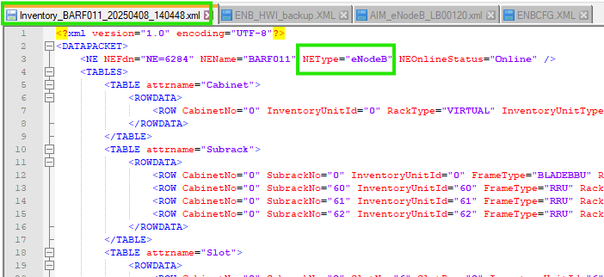
OAM IP | [Optional] | - = <IP> value under <attributes> under <OMCH> Class  - E.g.: <IP>10.166.249.9</IP>
OAM Subnet Mask | [Mandatory] | - = <MASK> value under <attributes> under <OMCH> Class  - E.g.: <MASK>255.255.255.0</MASK>

Networking Parameters

The networking attributes below defined at eNodeB level are as follows:

Attributes | Importance | Example
MCC | [Mandatory] | - Under class “<CnOperator>” the value of attribute “<Mcc>” will be MCC.  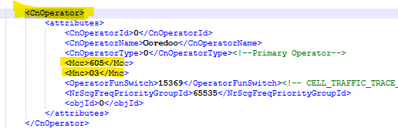
MNC | [Mandatory] | - Under class “<CnOperator>” the value of attribute “<Mnc>” will be MNC.
TAC list | [Optional] | - Under class “<CnOperatorTa>” the value of attribute “<Tac>” for all possible cells of any node.  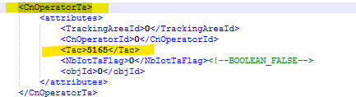
Operator | [Mandatory] | - = <CnOperatorName> value under <attributes> under <CnOperator> Class  - E.g.: <CnOperatorName>Ooredoo</CnOperatorName>
Parent MMEs | [Optional] | - To be deduced from S1-MME interfaces destination.
Parent SGWs | [Optional] | - To be deduced from S1-U interfaces destination.
Connected eNodeBs | [Optional] | - To be deduced from X2 interfaces destination.

Radio Parameters

The following table summarizes the radio attributes, which have default value at catalogue level but can be imported and editable at instance level.

Attribute | Importance | Example
Duplexing Mode | [Mandatory] | - Under class “<Cell>” the value of attribute “<FddTddInd> “:  If it is 1 then TDD  If it is 0 then FDD  Exp:  <FddTddInd>1</FddTddInd><!--TDD-->  <FddTddInd>0</FddTddInd><!--FDD-->
Operational Frequency Bands for FDD | [Optional] | - Get the value of attribute <FreqBand> under class <Cell> .  - The “Operational Frequency bands for FDD “will be a concatenation of “FDD”,” _” and the value of <FreqBand>.  - E.g.: FDD_42.  - Note: In case of different values of “FreqBand” were found list them all.  - FDD_42 , FDD_45, FDD_50
Operational Frequency Bands for TDD | [Optional] | - Get the value of attribute <FreqBand> under class <Cell> .  - The “Operational Frequency bands for FDD “will be a concatenation of “TDD”,” _” and the value of <FreqBand>.  - E.g.: TDD_42.  - Note: In case of different values of “FreqBand” were found list them all.  - TDD_42 , TDD_45, TDD_50
Supported Bandwidths | [Optional] | - Get the deduced Band value obtained from the Band column present in the “Operational Frequency bands for TDD” table or “Operational Frequency bands for FDD” table, and match it in the below table. Once matched, get the value of corresponding supported bandwidths:
  Band | Supported Bandwidths
  1 | 5, 10, 15, 20
  2 | 1.4, 3, 5, 10, 15, 20
  3 | 1.4, 3, 5, 10, 15, 20
  4 | 1.4, 3, 5, 10, 15, 20
  5 | 1.4, 3, 5, 10
  7 | 5, 10, 15, 20
  8 | 1.4, 3, 5, 10
  9 | 5, 10, 15, 20
  10 | 5, 10, 15, 20
  11 | 5, 10
  12 | 1.4, 3, 5, 10
  13 | 5, 10
  14 | 5, 10
  17 | 5, 10
  18 | 5, 10, 15
  19 | 5, 10, 15
  20 | 5, 10, 15, 20
  21 | 5, 10, 15
  22 | 5, 10, 15, 20
  23 | 1.4, 3, 5, 10
  24 | 5, 10
  25 | 1.4, 3, 5, 10, 15, 20
  26 | 1.4, 3, 5, 10, 15
  27 | 1.4, 3, 5, 10, 15
  28 | 5, 10, 15, 20
  28 | 5, 10
  30 | 5, 10
  33 | 5, 10, 15, 20
  34 | 5, 10, 15
  35 | 1.4, 3, 5, 10, 15, 20
  36 | 1.4, 3, 5, 10, 15, 20
  37 | 5, 10, 15, 20
  38 | 5, 10, 15, 20
  39 | 5, 10, 15, 20
  40 | 5, 10, 15, 20
  41 | 5, 10, 15, 20
  42 | 5, 10, 15, 20
  43 | 5, 10, 15, 20
  44 | 5, 10, 15, 20
Uplink 64-QAM support | [Optional] | - It is sufficient to have one "Qam64Enabled "equal to "1" so that the related node has "Uplink 64-QAM support".  - It is found under the following, ClassPUSCHCfgattributesQam64Enabled  - E.g.: <Qam64Enabled>1</Qam64Enabled>  - If it is 0 then not supported Uplink 64-QAM.
ICIC enabled | [Optional] | - It is sufficient that at least one of the below attributes value is equal to “1” so that “Support of ICIC” is enabled on this node otherwise not.  - The attributes to be checked are:  - “DlIcicSwitch” <DlIcicSwitch>0</DlIcicSwitch>  - “UlIcicTimeSwitch” <UlIcicTimeSwitch>0<UlIcicTimeSwitch>  - “UlIcicFreqSwitch” <UlIcicFreqSwitch>0</UlIcicFreqSwitch>  - Above attributes are found under, classENodeBAlgoSwitchattributes.

Status

If eNodeB is a standalone, then it is active or not?:

Status | [Optional] | - To be deduced from attribute <S1InterfaceIsBlock> under class <S1Interface>.  - If all S1InterfaceIsBlock under an eNodeB are equal to 0 then status = In-Active.  - Else, <S1InterfaceIsBlock> will be 1 & the status is Active.

If eNodeB is a role under SRAN, then Status to be added as customizable attribute:

Attribute | Category | Value
4G status | Status | - To be deduced from attribute <S1InterfaceIsBlock> under class <S1Interface>.  - If all S1InterfaceIsBlock under an eNodeB are equal to 0 then status = In-Active.  - Else, <S1InterfaceIsBlock> will be 1 & the status is Active.

Cell Logical Parameters

Attributes | Importance | Comment
Node ID | Mandatory | - The value of attribute <eNodeBId> under class <eNodeBFunction>.  Note: Node names will be found from an attribute <eNodeBFunctionName> under same class.
Cell ID | Mandatory | - Combination of <Node ID>-<LocalCell ID>  Node ID is taken from above step, and LocalCell ID is the value of attribute <LocalCellId > under class <Cell>.  e.g. if Node ID is 512011 and LocalCell ID is 23 then Cell ID is 512011-23.
Cell Name | Mandatory | - The value of an attribute <CellName> under class <Cell>.  - E.g.: <CellName>BARF011F23</CellName>
Neighbor Cells 2G | Optional | - Neighbour Cell 2G is represented with class <GeranNcell>.  - Neighbour Cell refers to the value of an attribute <LocalCellId> under class <Cell> is matching with the value of an attribute <LocalCellId> under class < GeranNcell>.  - Then Neighbour Cells 2G is equal to the concatenation of “LAC”, “_” and “GeranCellId”  GeranCellId extraction:  - = The value of an attribute <GeranCellId> under class <GeranNcell>.  LAC extraction:  - = The value of an attribute <Lac> under class <GeranNcell>.  - E.g.:  - <Lac>147</Lac>  - <GeranCellId>15721</GeranCellId>  - Neighbour Cells 2G = 147_15721
Neighbor Cells 3G | Optional | - Neighbour Cell 3G is represented with class <UtranNCell>.  - Neighbour Cell refers to the value of an attribute <LocalCellId> under class <Cell> is matching with the value of an attribute <LocalCellId> under class <UtranNCell>.  - Then Neighbour Cells 3G is equal to the concatenation of “LAC”, “_” and “CellId”:  - “LAC” deduction:  - Get the value of an attribute <CellId> under class < UtranNCell>.  - Find <UtranExternalCell> where the value of an attribute <CellId> class <UtranExternalCell> is matching with the value of <CellId> under class <UtranNCell>.  - “LAC” = <Lac> value under above class <UtranExternalCell>.  - CellId = The value of an attribute <CellId> under class <UtranNCell>.
Neighbor Cells 4G | Optional | - The “neighbours Cells 4G” is to be deduced through following two classes when available:  - <EutranIntraFreqNCell> and <EutranInterFreqNCell>  - Neighbour Cell refers to the Cell with the value of an attribute <LocalCellId> under class <Cell> is matching with the value of <LocalCellId> under classes <EutranIntraFreqNCell and <EutranInterFreqNCell.  - Find eNodeB with eNodeBId under eNodeBFunction is matching with eNodeBId under <EutranIntraFreqNCell> and <EutranInterFreqNCell>  - Find Cell under above deduced eNodeB with LocalCellId is matching with LocalCellId under <EutranIntraFreqNCell> and <EutranInterFreqNCell>  - Neighbour cell ID=ID of deduced cell.

Specific attributes for 4G cells

Attributes | Example | Comments
Cell Duplexing Mode | Optional | - Deduced the value of an attribute <FddTddInd> under class <Cell>.  - If equal to “0”, hence “Cell Duplexing Mode” is equal to FDD.  - Else if equal to “1”, “Cell Duplexing Mode” is equal to TDD.  - E.g.: <FddTddInd>0</FddTddInd>  - Value refers to the cell name mentioned under <CellName> attribute within the same class.
PCID | Optional | - = The value of an attribute <PhyCellId> under class <Cell>.  - Value refers to the cell name mentioned under <CellName> attribute within the same class.
TAC list | Optional | - = The value of an attribute <Tac> under class <CnOperatorTa>.  - This value is the same for all the cells under a specific node.
Downlink Bandwidths | Optional | - Downlink Bandwidth will be considered as the value which will come in-front (Before arrow) of attribute <DlBandWidth> under class <Cell>.  - Example: 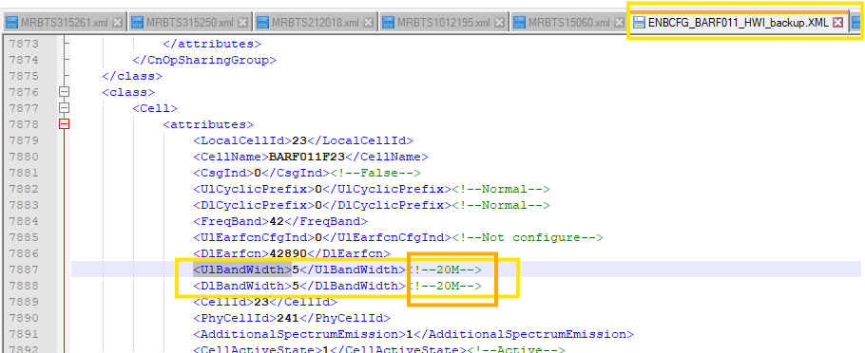  In this case the value of downlink bandwidth will be equal to 20 MHz.
Uplink Bandwidths | Optional | - Upnlink Bandwidth will be considered as the value which will come in-front (Before arrow) of attribute <UlBandWidth> under class <Cell>.  - Example:  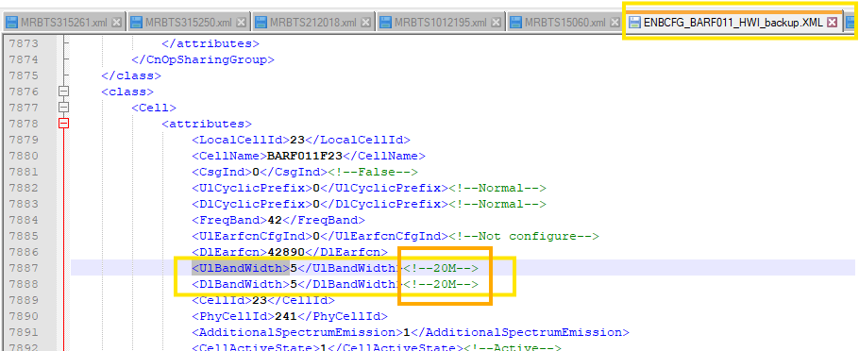  In this case the value of downlink bandwidth will be equal to 20 MHz.
Downlink EARFCN | Optional | - = The value of an attribute <DlEarfcn> under class <Cell>.  - Value refers to the cell name mentioned under <CellName> attribute within the same class.
Uplink EARFCN | Optional | - If “Cell Duplexing Mode” is equal to “FDD” then  “Uplink EARFCN” =“Downlink EARFCN” + 18000.  - Else If “Cell Duplexing Mode” is equal to “TDD” then  “Uplink EARFCN” = “Downlink EARFCN”.  - Value refers to the cell name mentioned under <CellName> attribute within the same class.
MIMO configuration | Optional | - Based on the value of an attribute <MimoAdaptiveSwitch> under class <MimoAdaptiveParaCfg> or <CellMimoParaCfg>.  - If value =0 ; Fixed MIMO  - If value=1 ; Open-loop adaptive MIMO  - If value=2 ; Closed-loop adaptive MIMO  - If value=3 ; Open/Closed-loop adaptive MIMO  MIMO Configuration: This detail will be available with an attribute <TxRxMode> within class <Cell>.  <TxRxMode>2</TxRxMode><!--2T2R-->  <TxRxMode>4</TxRxMode><!--4T4R-->
Cell status | [Optional] | - To be deduced from an attribute <CellActiveState> Under class <Cell>.  - If the value is 1, then Cell is in ACTIVE state.  - Else, the cell is in INACTIVE state.  If attribute/class is NA then consider inactive.

IP, VLAN, GW Parsing

Physical port IP

- Deduced from class <DEVIP>.

Attributes | Importance | Parsing
Interface Name | [Mandatory] | - =GE Cabinet/Shelf/Slot/Index on slot/port.  - E.g. GETH0/2/24/0/1
Physical Port C/Sh/S/I/P | [Mandatory] | - Cabinet, Shelf, Slot and Port indexes are equal to CN, SRN, SN and PN under attributes under DEVIP.  - Index on Slot=0.
IP address | [Optional] | - The value of an attribute <IP> under class <DEVIP>.  - If multiple IPs referring to same physical port, then consider the first as primary and the rest as secondary.
Subnet Mask | [Optional] | - The value of an attribute <Mask> under class <DEVIP>.
Gateway | [Optional] | - Find the IPs in the same range between attribute <IP> and <MASK> under class <DEVIP>.  - Gateway=<NEXTHOPIP> under class <VLANMAP>.  If not found, then take the value of <NEXTHOP> under class <IPRT>.
VLAN | [Optional] | - VLAN=VLANID under same VLANMAP class corresponding to NEXTHOPIP above.  - When VLANMODE=1 under class VLANMAP then take value of VLANGROUPNO under VLANMAP and search for VLANID under class VLANCLASS corresponding to same value of VLANGROUPNO

Addinfo

- Each class <USERPLANEPEER> with an attribute <REMOTEID> which has blank data represents one ADJNODE and one ASSOCIATION. (e.g.<REMOTEID></REMOTEID>)

Attribute | Category | Value | Note
Category_Value | ADJNODE | <UPPEERID> under class <USERPLANEPEER> | - CONNECTION_TYPE=S1-U  - NODE_ID= IP_DERIVED
Category_Value | ASSOCIATION  // 1st association // | <UPPEERID>  under class <USERPLANEPEER> | - LOCAL_IP= The value of <LOCIPV4> under class <USERPLANEHOST>  - REMOTE_IP= The value of <PEERIPV4> under class <USERPLANEPEER>

- Each <SCTPPEER> with an attribute <REMOTEID> which has blank data represents one ADJNODE and 2 ASSOCIATIONs.
(e.g. <REMOTEID></REMOTEID>)

Attribute | Category | Value | Note
Category_Value | ADJNODE | <SCTPPEERID> under class <SCTPPEER> | - CONNECTION_TYPE=S1-MME  - NODE_ID= IP_DERIVED
Category_Value | ASSOCIATION  // 1st association // | <SCTPPEERID> under class <SCTPPEER> | - LOCAL_IP= the value of <SIGIP1V4> under class <SCTPHOST>, if value = 0.0.0.0 then ignore this association.  - If multiple <SCTPHOST> were found, then take one randomly.  - REMOTE_IP= the value of <SIGIP1V4> under class <SCTPPEER>, if value = 0.0.0.0 then ignore this association.
Category_Value | ASSOCIATION  // 2nd association // | <SCTPPEERID> under class <SCTPPEER> | - LOCAL_IP= the value of <SIGIP2V4> under class <SCTPHOST>, if value = 0.0.0.0 then take value of <SIGIP1V4>.  - If multiple <SCTPHOST> were found, then take one randomly.  - REMOTE_IP= the value of <SIGIP2V4> under class <SCTPPEER>, if value = 0.0.0.0 then ignore this association.

Interfaces (Need to cross check once again & for SRAN which support as 4G)

S1-MME Interface (Auto Configured)

- Each S1-MME interface is represented with one <S1> Class in logical dumps.
- S1-MME interface has one associated <EPGROUP> class where <CpEpGroupId> under <attributes> under <S1> class is matching with <EPGROUPID> under <attributes> <EPGROUP> class.
- <EPGROUP> class has an associated <SCTPHOST> class where <SCTPHOSTID> under <element> under <SCTPHOSTREFS> under <attributes> under <EPGROUP> class is matching with <SCTPHOSTID> under <attributes> under <SCTPHOST> class.
- <EPGROUP> class has an associated <SCTPPEER> class where <SCTPPEERID> under <element> under <SCTPPEERREFS> under <attributes> under <EPGROUP> class is matching with <SCTPPEERID> under <attributes> under <SCTPPEER> class.
- Below are the attributes of an S1-MME interface:

Attributes | Importance | Example
Interface Name | [Mandatory] | - Is the concatenation of “eNodeB Name”, “_” and “MME Name”
Interface Type | [Mandatory] | - “S1-MME”.
eNodeB Name | [Mandatory] | - = <eNodeBFunctionName> value under <attributes> under <eNodeBFunction> Class.
eNodeB C/Sh/S/I/P | [Mandatory] | - Find <DEVIP> Class with <IP> attribute under <attributes> under <DEVIP> class is matching with <SIGIP1V4> or <SIGIP2V4> attribute under <attributes> under <SCTPHOST> class.  - Cabinet, Shelf, Slot and Port are equal to <CN>, <SRN>, <SN> and <PN> attributes under<DEVIP> class respectively.  - Index on Slot=0.
MME Name | [Mandatory] | - If <REMOTEID> attribute under <attributes> under <SCTPPEER> Class is not null, then ignore this SCTPPEER.  - Get <SIGIP1V4> and <SIGIP2V4> attribute under <attributes> under <SCTPPEER> Class.  - Priority 1:  - Find MME with LOCALIPV4_1 or LOCALIPV4_2 under ADD S1APLE tag in MME is matching with above <SIGIP1V4> or <SIGIP2V4>.  - MME name is the name of above deduced node.  - Priority 2:  - Find in parentMmeMatching.xlsx file in column D the IP matching with <SIGIP1V4> or <SIGIP2V4>.  - = value in correspondent Column B in parentMmeMatching.xlsx file.
eNodeB IP | [Optional] | - = <IP> attribute under <attributes> under <DEVIP> Class.
eNodeB Subnet Mask | [Optional] | - = <Mask> attribute under <attributes> under <DEVIP> Class.
MME C/Sh/S/I/P | [Optional] | - Priority 1:  - From IP and MSK attributes under all “ADD IPRT” in MME find the range of valid Connected IPs for each "ADD IPRT".  - Find "ADD IPRT" with IP range including eNodeB IPs.  - Get GATE under above deduced "ADD IPRT".  - From IP and MSK attributes under all “ADD IFIP” in MME find the range of valid Connected IPs for each "ADD IFIP".  - Find "ADD IFIP" with IP range including above deduced GATE under "ADD IPRT".  - Shelf, Slot and port indexes are equal to “SRN”, “SN” and “PN” under "ADD IFIP".  - Index on Slot =1.  - Multiple ports might be found.  - Priority 2:  - Get <SIGIP1V4> and <SIGIP2V4> attribute under <attributes> under <SCTPPEER> Class.  - Match <SIGIP1V4> or <SIGIP2V4> with BRDIP attribute under ADD VRFBRDIPBIND tag in MME dump  - Take the value of VRFNAME attribute  - Match it with VRFNAME under ADD DFTRT  - Take the value of GATE attribute  - From IP and MSK attributes under all “ADD IFIP” in MME find the range of valid Connected IPs for each "ADD IFIP".  - Find "ADD IFIP" with IP range including above deduced GATE under "ADD DFTRT ".  - Shelf, Slot and port indexes are equal to “SRN”, “SN” and “PN” under "ADD IFIP".  - Index on Slot =1.  - Multiple ports might be found.  - Priority 3  - = value in correspondent Column C in parentMmeMatching.xlsx file.
MME IP | [Optional] | - Priority 1:  - = IP under ADD IFIP in MME dump.  - Priority 2:  - = value in correspondent Column E in parentMmeMatching.xlsx file.
MME Subnet Mask | [Optional] | - Priority 1:  - =MSK under ADD IFIP in MME dump.  - Priority 2:  - = value in correspondent Column F in parentMmeMatching.xlsx file.
ENodeB Gateway | [Mandatory] | - Find <IPRT> with <DstIP> under <attributes> under <IPRT> is matching with <<SIGIP1V4> or <SIGIP2V4> attribute under <attributes> under <SCTPPEER> Class.  - If not found, then:  - From <DSTIP> and <DSTMASK> under each <IPRT> get the range of all connected IPs for each <IPRT>.  - Find <IPRT> with <<SIGIP1V4> or <SIGIP2V4> are included in its range.  - Gateway = <NextHop> under same <IPRT>.
ENodeB Vlan | [Mandatory] | - Find <VLANMAP> with <NextHopIP> is matching with <NextHop> under above deduced <IPRT>.  - VLAN = <VLANID> under same <VLANMAP>.
MME Gateway | [Mandatory] | - Priority 1:  - = “GATE” attribute under above deduced “ADD IPRT” in MME dump.  - Priority 2:  - = “GATE” attribute under above deduced “ADD DFTRT” in MME dump.  - Priority 3:  - = value in correspondent Column G in parentMmeMatching.xlsx file.  - For Zain Kuwait:  - = <SCTPPEERID> that was deduced from eNodeB
MME Vlan | [Mandatory] | - Priority 1:  - =Null  - Priority 2:  - = value in correspondent Column H in parentMmeMatching.xlsx file.

S1-MME Interface (Manually Configured)

- Each S1-MME interface is represented with one <S1interface> Class in logical dumps.
- S1-MME interface has one associated <CPBEARER> class where <CPBEARID> under <attributes> under <CPBEARER> class is matching with <S1CpBearerId> under <attributes> under <S1Interface> class.
- <CPBEARER> class has an associated <SCTPLNK> class where <SCTPNO> under <SCTPLNK> class is matching with <LINKNO> under <attributes> under <CPBEARER> class.
- Below are the attributes of an S1-MME interface:

Attributes | Importance | Example
Interface Name | [Mandatory] | - Is the concatenation of “eNodeB Name” , “_” and “MME Name”
Interface Type | [Mandatory] | - “S1-MME”.
eNodeB Name | [Mandatory] | - = <eNodeBFunctionName> value under <attributes> under <eNodeBFunction> Class.
eNodeB C/Sh/S/I/P | [Mandatory] | - Find <DEVIP> Class with <IP> attribute under <attributes> under <DEVIP> class is matching with <LOCIP> under <attributes> under <SCTPLNK> class.  - Cabinet, Shelf, Slot and Port are equal to <CN>, <SRN>, <SN> and <PN> attributes under<DEVIP> class respectively.  - Index on Slot=0.
MME Name | [Mandatory] | - Get <PEERIP> and <SECPEERIP> attributes under <attributes> under <SCTPLNK> Class.  - If <SECPEERIP> is equal to 0.0.0.0 then ignore it.  - Priority 1:  - Find MME with LOCALIPV4_1 or LOCALIPV4_2 under ADD S1APLE tag in MME is matching with above <PEERIP> or <SECPEERIP>.  - MME name is the name of above deduced node.  - Priority 2:  - Find in parentMmeMatching.xlsx file in column D the IP matching with <PEERIP> or <SECPEERIP>.  - = value in correspondent Column B in parentMmeMatching.xlsx file.
eNodeB IP | [Optional] | - = <IP> attribute under <attributes> under <DEVIP> Class.
eNodeB Subnet Mask | [Optional] | - = <Mask> attribute under <attributes> under <DEVIP> Class.
MME C/Sh/S/I/P | [Optional] | - Priority 1:  - From IP and MSK attributes under all “ADD IPRT” in MME find the range of valid Connected IPs for each "ADD IPRT".  - Find "ADD IPRT" with IP range including eNodeB IPs.  - Get GATE under above deduced "ADD IPRT".  - From IP and MSK attributes under all “ADD IFIP” in MME find the range of valid Connected IPs for each "ADD IFIP".  - Find "ADD IFIP" with IP range including above deduced GATE under "ADD IPRT".  - Shelf, Slot and port indexes are equal to “SRN”, “SN” and “PN” under "ADD IFIP".  - Index on Slot =1.  - Multiple ports might be found.  - Priority 2:  - = value in correspondent Column C in parentMmeMatching.xlsx file.
MME IP | [Optional] | - Priority 1:  - = IP under ADD IFIP in MME dump.  - Priority 2:  - = value in correspondent Column E in parentMmeMatching.xlsx file.
MME Subnet Mask | [Optional] | - Priority 1:  - =MSK under ADD IFIP in MME dump.  - Priority 2:  - = value in correspondent Column F in parentMmeMatching.xlsx file.
ENodeB Gateway | [Mandatory] | - Find <IPRT> with <DstIP> under <attributes> under <IPRT> is matching with <PEERIP> or <SECPEERIP> attributes under <attributes> under <SCTPLNK> Class.  - If not found then:  - From <DSTIP> and <DSTMASK> under each <IPRT> get the range of all connected IPs for each <IPRT>.  - Find <IPRT> with <PEERIP> or <SECPEERIP> are included in its range.  - Gateway = <NextHop> under same <IPRT>.
ENodeB Vlan | [Mandatory] | - Find <VLANMAP> with <NextHopIP> is matching with <NextHop> under above deduced <IPRT>.  - VLAN = <VLANID> under same <VLANMAP>.
MME Gateway | [Mandatory] | - Priority 1:  - = “GATE” attribute under above deduced “ADD IPRT” in MME dump.  - Priority 2:  - = value in correspondent Column G in parentMmeMatching.xlsx file.
MME Vlan | [Mandatory] | - Priority 1:  - =Null  - Priority 2:  - = value in correspondent Column H in parentMmeMatching.xlsx file.

S1-U Interface (Auto-Configured)

- Each S1-U interface is represented with one <S1> Class in logical dumps.
- S1-U interface has one associated <EPGROUP> class where <UpEpGroupId> under <attributes> under <S1> class is matching with <EPGROUPID> under <attributes> <EPGROUP> class.
- <EPGROUP> class has an associated <USERPLANEHOST> class where <UPHOSTID> under <element> under <USERPLANEHOSTREFS> under <attributes> under <EPGROUP> class is matching with <UPHOSTID> under <attributes> under <USERPLANEHOST> class.
- <EPGROUP> class has an associated <USERPLANEPEER> class where <UPPEERID> under <element> under <USERPLANEPEERREFS> under <attributes> under <EPGROUP> class is matching with <UPPEERID> under <attributes> under <USERPLANEPEER> class.
- Below are the attributes of an S1-U interface:

Attributes | Importance | Example
SGW Name | [Mandatory] | - Priority 1:  - Find SGW with ip address under # interface is matching with <PEERIPV4> under <attributes> under <USERPLANEPEER> in eNodeB.  - Priority 2:  - Get <PEERIPV4> under <attributes> under <USERPLANEPEER>.  - Find in parentMmeMatching.xlsx file in column D the IP matching with SGW IP address.  - SGW Name equals value in Column B in parentMmeMatching.xlsx file matching with the IP address.
Interface Name | [Mandatory] | - Is the concatenation of “eNodeB Name” , “_” and “SGW Name”
Interface Type | [Mandatory] | - “S1-U”
eNodeB Name | [Mandatory] | - = <eNodeBFunctionName> value under <attributes> under <eNodeBFunction> Class
eNodeB C/Sh/S/I/P | [Mandatory] | - Find <DEVIP> Class with <IP> attribute under <attributes> under <DEVIP> class is matching with <LOCIPV4> attribute under <attributes> under <USERPLANEHOST> class.  - Cabinet, Shelf, Slot and Port are equal to <CN>, <SRN>, <SN> and <PN> attributes under<DEVIP> class respectively.
eNodeB IP | [Optional] | - = <IP> attribute under <attributes> under <DEVIP> Class.
eNodeB Subnet Mask | [Optional] | - = <Mask> attribute under <attributes> under <DEVIP> Class.
SGW Virtual Interface | [Optional] | - =True
SGW Interface Name | [Optional] | - Priority1:  - Find # interface in SGW with first part of ip address under # interface is matching with <PEERIPV4> under <attributes> under <USERPLANEPEER> in eNodeB (e.g. interface S1-uif2/1/0).  - Get ip binding vpn-instance under above #interface.  - Find tags in SGW starting with #interface Eth-Trunk with ip binding vpn-instance under #interface Eth-Trunk is matching with ip binding vpn-instance (e.g. interface Eth-Trunk23).  - Interface Name= value following #interface (e.g. Eth-Trunk3.27)  - Priority2:  - = value in correspondent Column C in parentMmeMatching.xlsx file.
SGW IP | [Optional] | - Priority1:  - = First part of ip address under above #interface Eth-Trunk.  - Priority2:  - = value in correspondent Column E in parentMmeMatching.xlsx file.
SGW Subnet Mask | [Optional] | - Priority1:  - = Last part of ip address under above #interface Eth-Trunk.  - Priority2:  - = value in correspondent Column F in parentMmeMatching.xlsx file.
ENodeB Gateway | [Mandatory] | - Find <IPRT> with <DstIP> under <attributes> under <IPRT> is matching with <PEERIPV4> attribute under <attributes> under <USERPLANEPEER> Class  - If not found then:  - From <DSTIP> and <DSTMASK> under each <IPRT> get the range of all connected IPs for each <IPRT>.  - Find <IPRT> with <PEERIPV4> is included in its range.  - Gateway = <NextHop> under same <IPRT>.
ENodeB Vlan | [Mandatory] | - Find <VLANMAP> with <NextHopIP> is matching with <NextHop> under above deduced <IPRT>.  - VLAN = <VLANID> under same <VLANMAP>.
SGW Gateway | [Mandatory] | - Priority1:  - = Null  - Priority2:  - = value in correspondent Column G in parentMmeMatching.xlsx file.
SGW Vlan | [Mandatory] | - Priority1:  - = Null  - Priority2:  - = value in correspondent Column H in parentMmeMatching.xlsx file.

S1-U Interface (Manually-Configured)

- Each S1-U interface is represented with one <eNodeBPath> Class in logical dumps where <AppType> under <attributes> under <eNodeBPath> is equal to “0”.
- S1-U interface has one associated <IPPATH> class where <PATHID> under <attributes> under <IPPATH> class is matching with <IpPathId> under <attributes> under <eNodeBPath> class.
- Below are the attributes of an S1-U interface:

Attributes | Importance | Example
SGW Name | [Mandatory] | - Get SGW IP address.  - Find in parentMmeMatching.xlsx file in column D the IP matching with SGW IP address.  - SGW Name equals value in Column B in parentMmeMatching.xlsx file matching with the IP address.
Interface Name | [Mandatory] | - Is the concatenation of “eNodeB Name” , “_” and “SGW Name”
Interface Type | [Mandatory] | - “S1-U”
eNodeB Name | [Mandatory] | - = <eNodeBFunctionName> value under <attributes> under <eNodeBFunction> Class
eNodeB C/Sh/S/I/P | [Mandatory] | - Find <DEVIP> Class with <IP> attribute under <attributes> under <DEVIP> class is matching with <LOCALIP> attribute under <attributes> under <IPPATH> class.  - Cabinet, Shelf, Slot and Port are equal to <CN>, <SRN>, <SN> and <PN> attributes under<DEVIP> class respectively.
eNodeB IP | [Optional] | - = <IP> attribute under <attributes> under <DEVIP> Class.
eNodeB Subnet Mask | [Optional] | - = <Mask> attribute under <attributes> under <DEVIP> Class.
SGW C/Sh/S/I/P | [Optional] | - = value in correspondent Column C in parentMmeMatching.xlsx file.
SGW IP | [Optional] | - = value in correspondent Column E in parentMmeMatching.xlsx file.
SGW Subnet Mask | [Optional] | - = value in correspondent Column F in parentMmeMatching.xlsx file.
ENodeB Gateway | [Mandatory] | - Find <IPRT> with <DstIP> under <attributes> under <IPRT> is matching with <PEERIP> attribute under <attributes> under <IPPATH> Class  - If not found then:  - From <DSTIP> and <DSTMASK> under each <IPRT> get the range of all connected IPs for each <IPRT>.  - Find <IPRT> with <PEERIP> is included in its range.  - Gateway = <NextHop> under same <IPRT>.
ENodeB Vlan | [Mandatory] | - Find <VLANMAP> with <NextHopIP> is matching with <NextHop> under above deduced <IPRT>.  - VLAN = <VLANID> under same <VLANMAP>.
SGW Gateway | [Mandatory] | - = value in correspondent Column G in parentMmeMatching.xlsx file.
SGW Vlan | [Mandatory] | - = value in correspondent Column H in parentMmeMatching.xlsx file.

X2-Interface (Auto Configured)

- Each X2 interface is represented with one <X2> Class in logical dumps.
- X2 interface has one associated <EPGROUP> class where <UpEpGroupId> under <attributes> under <X2> class is matching with <EPGROUPID> under <attributes> <EPGROUP> class.
- <EPGROUP> class has an associated <USERPLANEHOST> class where <UPHOSTID> under <element> under <USERPLANEHOSTREFS> under <attributes> under <EPGROUP> class is matching with <UPHOSTID> under <attributes> under <USERPLANEHOST> class.
- <EPGROUP> class has an associated <USERPLANEPEER> class where <UPPEERID> under <element> under <USERPLANEPEERREFS> under <attributes> under <EPGROUP> class is matching with <UPPEERID> under <attributes> under <USERPLANEPEER> class.
- Below are the attributes of an X2 interface:

Attributes | Importance | Example
eNodeB2 Name | [Mandatory] | - ENodeB2 ID to be deduced from <REMOTEID> under <attributes> under <USERPLANEPEER> Class.  - <REMOTEID> format is eNB:MCC_X MNC_y GlobaleNBId_X-Y-Z, ENodeB2 ID =Z.  - E.g. <REMOTEID>eNB:MCC_655 MNC_01 GlobaleNBId_655-01-119281</REMOTEID> → ENodeB2 ID =119281.  - ENodeB2 Name = Node Name of above deduced Node ID in physical configuration.  - ENodeB1 should be connected to EnodeB2 via X2 interface as per the procedure described above, else interface to be ignored.
Interface Name | [Mandatory] | - Is the concatenation of “ENodeB1 Name” , “_” and “ENodeB2 Name”
Interface Type | [Mandatory] | - “X2”
eNodeB1 Name | [Mandatory] | - = <eNodeBFunctionName> value under <attributes> under <eNodeBFunction> Class
eNodeB1 C/Sh/S/I/P | [Mandatory] | - Find <DEVIP> Class with <IP> attribute under <attributes> under <DEVIP> class is matching with <LOCIPV4> attribute under <attributes> under <USERPLANEHOST> class.  - Cabinet, Shelf, Slot and Port are equal to <CN>, <SRN>, <SN> and <PN> attributes under<DEVIP> class respectively.
eNodeB1 IP | [Optional] | - = <IP> attribute under <attributes> under <DEVIP> Class.
eNodeB1 Subnet Mask | [Optional] | - = <Mask> attribute under <attributes> under <DEVIP> Class.
ENodeB1 Gateway | [Mandatory] | - Find <IPRT> with <DstIP> under <attributes> under <IPRT> is matching with <PEERIPV4> under <attributes> under <USERPLANEPEER>  - If not found then:  - From <DSTIP> and <DSTMASK> under each <IPRT> get the range of all connected IPs for each <IPRT>.  - Find <IPRT> with <PEERIPV4> is included in its range.  - Gateway = <NextHop> under same <IPRT>.
ENodeB1 Vlan | [Mandatory] | - Find <VLANMAP> with <NextHopIP> is matching with <NextHop> under above deduced <IPRT>.  - VLAN = <VLANID> under same <VLANMAP>.
ENodeB2 Gateway | [Mandatory] | - Find <IPRT> with <DstIP> under <attributes> under <IPRT> is matching with <PEERIPV4> under <attributes> under <USERPLANEPEER>  - If not found then:  - From <DSTIP> and <DSTMASK> under each <IPRT> get the range of all connected IPs for each <IPRT>.  - Find <IPRT> with <PEERIPV4> is included in its range.  - Gateway = <NextHop> under same <IPRT>.
ENodeB2 Vlan | [Mandatory] | - Find <VLANMAP> with <NextHopIP> is matching with <NextHop> under above deduced <IPRT>.  - VLAN = <VLANID> under same <VLANMAP>.
ENodeB2 C/Sh/S/I/P | [Optional] | - Find the logical dump file of destination eNodeB.  - Find in the logical dump file of destination eNodeB the <USERPLANEPEER> Class with <REMOTEID> containing the ID of source eNodeB.  - Find in the logical dump file of destination eNodeB the <EPGROUP> class with <UPPEERID> under <element> under <USERPLANEPEERREFS> under <attributes> under <EPGROUP> class is matching with <UPPEERID> under <attributes> under <USERPLANEPEER> class.  - Get <UPHOSTID> under <element> under <USERPLANEHOSTREFS> under <attributes> under <EPGROUP> class in the destination NodeB dump.  - Find <USERPLANEHOST> class where UPHOSTID> under <element> under <USERPLANEHOSTREFS> under <attributes> under <EPGROUP> class is matching with <UPHOSTID> under <attributes> under <USERPLANEHOST> class in the destination eNodeB dump.  - Find <DEVIP> Class with <IP> attribute under <attributes> under <DEVIP> class is matching with <LOCIPV4> attribute under <attributes> under <USERPLANEHOST> class in the destination eNodeB dump.  - Cabinet, Shelf, Slot and Port are equal to <CN>, <SRN>, <SN> and <PN> attributes under<DEVIP> class respectively in the destination eNodeB dump.
ENodeB2 IP | [Optional] | - = <IP> attribute under <attributes> under <DEVIP> Class in the destination eNodeB dump.
ENodeB2 Subnet Mask | [Optional] | - = <Mask> attribute under <attributes> under <DEVIP> Class in the destination eNodeB dump.
TX BW | [Optional] | - =Null
RX BW | [Optional] | - =Null

X2-Interface (Manually Configured)

- Each X2 interface is represented with one <eNodeBPath> Class in logical dumps where <AppType> under <attributes> under <eNodeBPath> is equal to “1”.
- X2 interface has one associated <IPPATH> class where <PATHID> under <attributes> under <IPPATH> class is matching with <IpPathId> under <attributes> under <eNodeBPath> class.
- Below are the attributes of an X2 interface:

Attributes | Importance | Example
eNodeB2 Name | [Mandatory] | - Find ENodeB with <IP> under <attributes> under <DEVIP> is matching with <PEERIP> under <attributes> under <IPPATH>.  - eNodeB2 should have  - = <eNodeBFunctionName> value under <attributes> under <eNodeBFunction> Class of above found enodeB.  - ENodeB1 should be connected to EnodeB2 via X2 interface as per the procedure described above, else interface to be ignored.
Interface Name | [Mandatory] | - Is the concatenation of “ENodeB1 Name” , “_” and “ENodeB2 Name”
Interface Type | [Mandatory] | - “X2”
eNodeB1 Name | [Mandatory] | - = <eNodeBFunctionName> value under <attributes> under <eNodeBFunction> Class of EnodeB1.
eNodeB1 C/Sh/S/I/P | [Mandatory] | - Find <DEVIP> Class with <IP> attribute under <attributes> under <DEVIP> class is matching with <LOCALIP> attribute under <attributes> under <IPPATH> class.  - Cabinet, Shelf, Slot and Port are equal to <CN>, <SRN>, <SN> and <PN> attributes under<DEVIP> class respectively.
eNodeB1 IP | [Optional] | - = <IP> attribute under <attributes> under <DEVIP> Class.
eNodeB1 Subnet Mask | [Optional] | - = <Mask> attribute under <attributes> under <DEVIP> Class.
ENodeB1 Gateway | [Mandatory] | - Find <IPRT> with <DstIP> under <attributes> under <IPRT> is matching with <PEERIP> attribute under <attributes> under <IPPATH> Class  - If not found then:  - From <DSTIP> and <DSTMASK> under each <IPRT> get the range of all connected IPs for each <IPRT>.  - Find <IPRT> with <PEERIP> is included in its range.  - Gateway = <NextHop> under same <IPRT>.
ENodeB1 Vlan | [Mandatory] | - Find <VLANMAP> with <NextHopIP> is matching with <NextHop> under above deduced <IPRT>.  - VLAN = <VLANID> under same <VLANMAP>.
ENodeB2 C/Sh/S/I/P | [Optional] | - Cabinet, Shelf, Slot and Port are equal to <CN>, <SRN>, <SN> and <PN> attributes under<DEVIP> class respectively.
ENodeB2 IP | [Optional] | - = <IP> attribute under <attributes> under <DEVIP> Class in the destination eNodeB dump.
ENodeB2 Subnet Mask | [Optional] | - = <Mask> attribute under <attributes> under <DEVIP> Class in the destination eNodeB dump.
ENodeB2 Gateway | [Mandatory] | - Find <IPRT> with <DstIP> under <attributes> under <IPRT> is matching with <PEERIP> attribute under <attributes> under <IPPATH> Class  - If not found then:  - From <DSTIP> and <DSTMASK> under each <IPRT> get the range of all connected IPs for each <IPRT>.  - Find <IPRT> with <PEERIP> is included in its range.  - Gateway = <NextHop> under same <IPRT>.
ENodeB2 Vlan | [Mandatory] | - Find <VLANMAP> with <NextHopIP> is matching with <NextHop> under above deduced <IPRT>.  - VLAN = <VLANID> under same <VLANMAP>.

Software Version

- Below additional info is to parse the node software version and backup software version for SRAN nodes.
- Add info need to be parsed from the physical dump of the SRAN nodes.
- Need to be consider for the dump which has all below 3 attributes.
<TABLE attrname="UCELL">
<TABLE attrname="GCELL">
<TABLE attrname="LCELL">

For Example: SOFTWARE_VERSION_4G = "BTS3900_5900 V100R019C10SPC260"

<ROW HostVerType="eNodeBFunctionHOSTVER" HostVer="BTS3900_5900 V100R019C10SPC260" sDesc="LRAT SOFTWARE VERSION" />

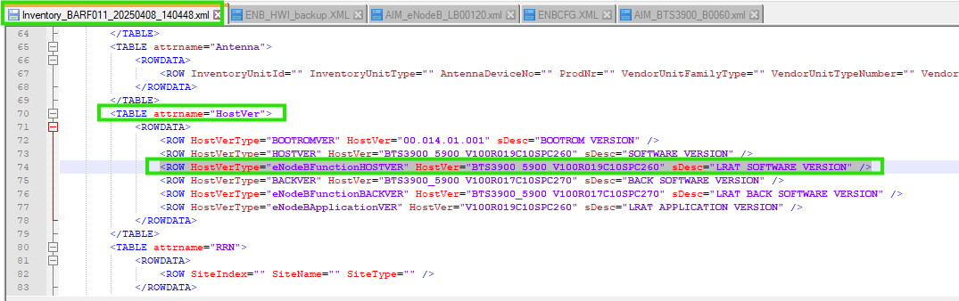

BACKUP_SOFTWARE_VERSION_4G: "BTS3900_5900 V100R017C10SPC270"

<ROW HostVerType="eNodeBFunctionBACKVER" HostVer="BTS3900_5900 V100R017C10SPC270" sDesc="LRAT BACK SOFTWARE VERSION" />

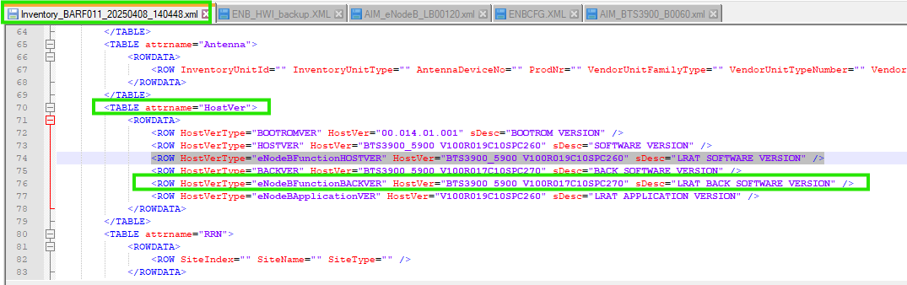

Attribute | Category | Value
SOFTWARE_VERSION_4G | SOFTWARE_VERSION | Take the value of “HostVer=” attribute where HostVerType="eNodeBFunctionHOSTVER" under class “<TABLE attrname="HostVer">”  Example given in above SS.
BACKUP_SOFTWARE_VERSION_4G | BACKUP_SOFTWARE_VERSION | Take the value of “HostVer=” attribute where HostVerType="eNodeBFunctionBACKVER"  under class “<TABLE attrname="HostVer">”  Example given in above SS.

